<https://www.ndtjames.com/54_Khz_Ultrasonic_Transducer_p/v-c-4898.htm>

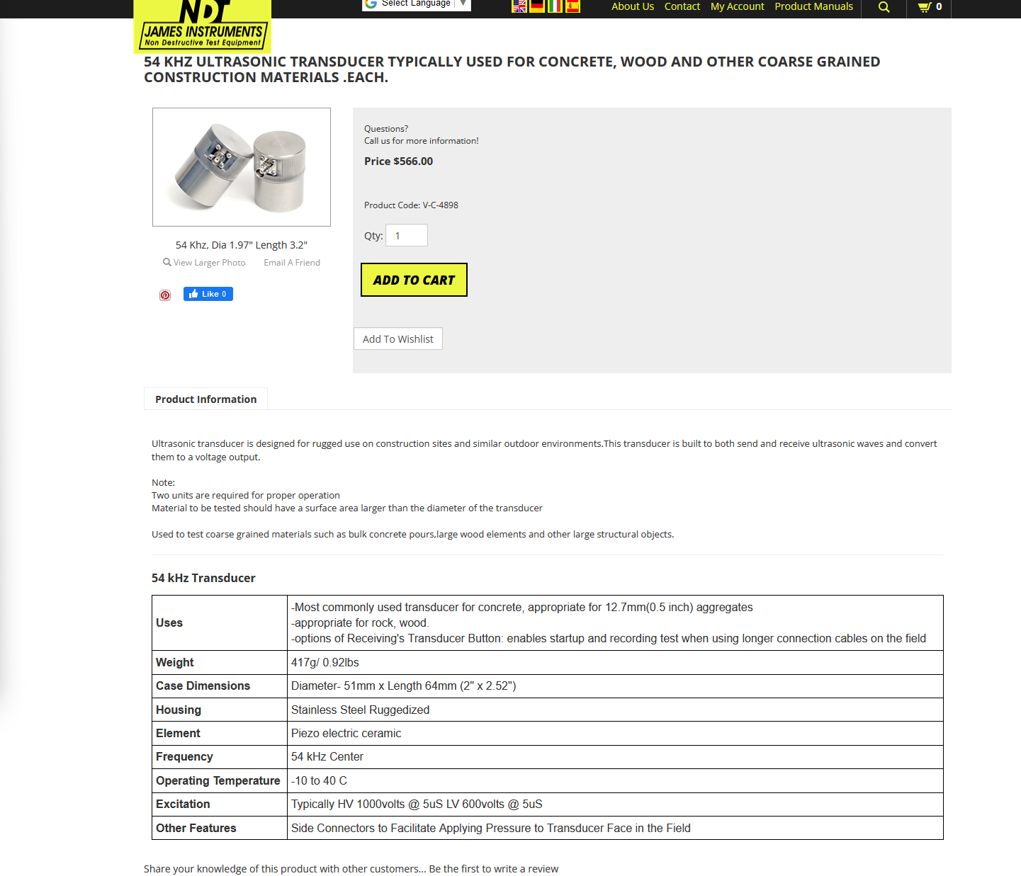

Excitation Typically HV 1000volts @ 5uS LV 600volts @ 5uS

<https://www.ndtjames.com/Ultrasonic-Transducers_a/315.html>

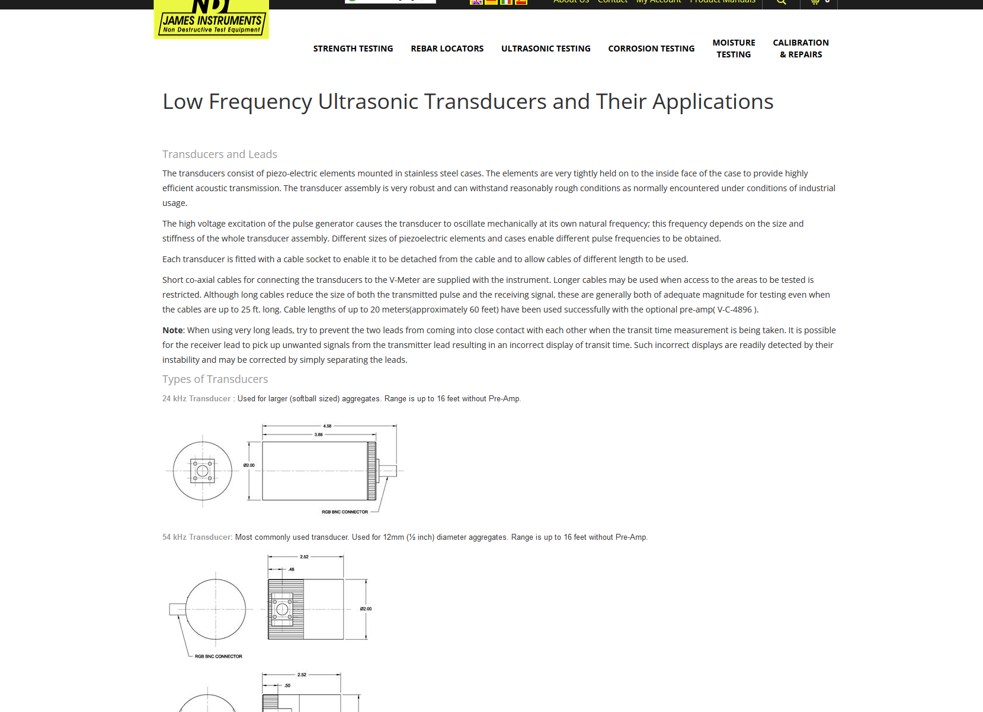

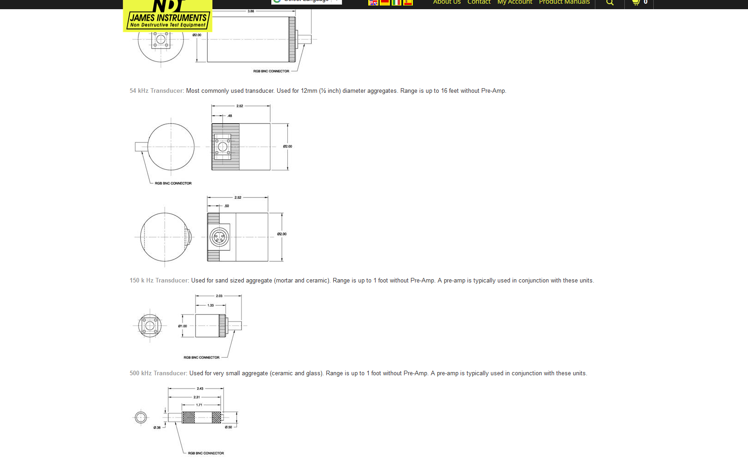

<https://onestoptesting.co.uk/wp-content/uploads/2016/04/V-C-9900.pdf>

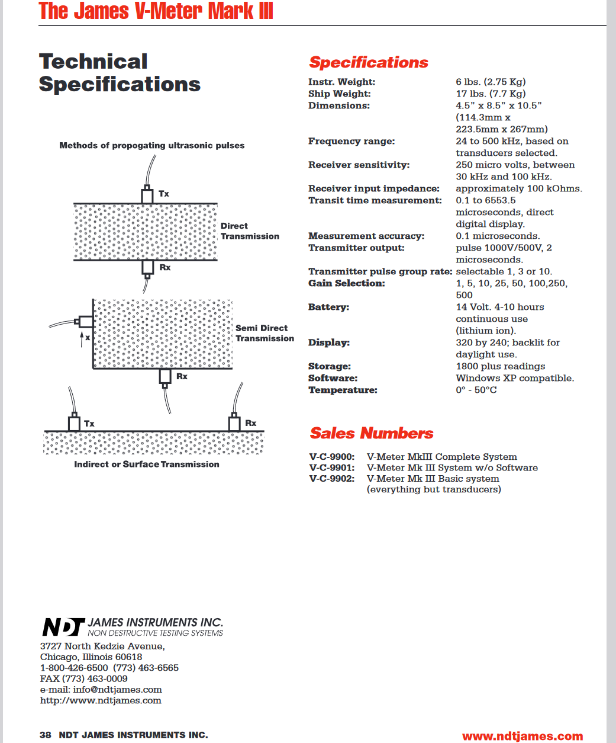

500kHz

https://www.ndtjames.com/500_Khz_Dia_6_0_Mm_p/v-c-7217.htm

